Experiment 5
Online Flight Reservation System

Aim
To develop an Online Flight Reservation System that allows users to search flights, check seat availability, book tickets, make payments, view and print tickets, and cancel reservations. The admin can manage flight details, bookings, customer feedback, and reports.
Procedure
- Create a webpage using HTML for flight reservations.
- Add user login, registration, and forgot password options.
- Provide flight search by destination, date, and travel class.
- Display flight details, fares, and seat availability.
- Allow users to enter passenger details and book tickets.
- Add payment, ticket viewing, printing, and cancellation options.
- Provide a customer feedback form.
- Create an admin section to manage flights, bookings, and reports.
- Test the webpage to verify its basic functions.

Sample Code
<!DOCTYPE html>
<html>
<head>
<title>Flight Reservation System</title>
</head>
<body>
<h1>Online Flight Reservation</h1>

<h2>User Login</h2>
<input placeholder="Username">
<input type="password" placeholder="Password">
<button>Login</button>
<button>Register</button>
<a href="#forgot">Forgot Password?</a>

<h2>Search Flight</h2>
<input id="from" placeholder="From">
<input id="to" placeholder="Destination">
<input type="date" id="date">

<select id="classType">
<option>Economy</option>
<option>Business</option>
<option>First Class</option>
</select>

<button onclick="searchFlight()">Search</button>
<p id="result"></p>

<h2>Book Ticket</h2>
<input id="name" placeholder="Passenger Name">
<button onclick="bookTicket()">Book Ticket</button>
<p id="ticket"></p>

<h2>Payment</h2>
<button onclick="pay()">Pay ₹5000 (Demo)</button>
<p id="payment"></p>

<h2>My Ticket</h2>
<button onclick="printTicket()">Print Ticket</button>
<button onclick="cancelTicket()">Cancel Ticket</button>

<h2>Customer Feedback</h2>
<textarea id="feedback" placeholder="Enter feedback"></textarea>
<button onclick="submitFeedback()">Submit</button>
<p id="message"></p>

<h2>Admin Panel</h2>
<p>Manage flights, bookings, seat availability and reports.</p>

<script>
let booked = false;

function searchFlight() {
let from = document.getElementById("from").value;
let to = document.getElementById("to").value;

if (!from || !to) {
alert("Enter departure and destination.");
return;
}

document.getElementById("result").innerHTML =
"Flight: " + from + " to " + to +
"<br>Available Seats: 20 (Sample)" +
"<br>Fare: ₹5000";
}

function bookTicket() {
let name = document.getElementById("name").value;

if (!name) {
alert("Enter passenger name.");
return;
}

booked = true;
document.getElementById("ticket").innerHTML =
"Passenger: " + name +
"<br>Flight Ticket: Sample Booking";
}

function pay() {
if (!booked) {
alert("Please book a ticket first.");
return;
}

document.getElementById("payment").textContent =
"Demo payment successful.";
}

function printTicket() {
if (booked) {
window.print();
} else {
alert("Please book a ticket first.");
}
}

function cancelTicket() {
booked = false;
document.getElementById("ticket").textContent =
"Ticket cancelled (Demo).";
document.getElementById("payment").textContent = "";
}

function submitFeedback() {
document.getElementById("message").textContent =
"Thank you for your feedback!";
}
</script>
</body>
</html>

Output
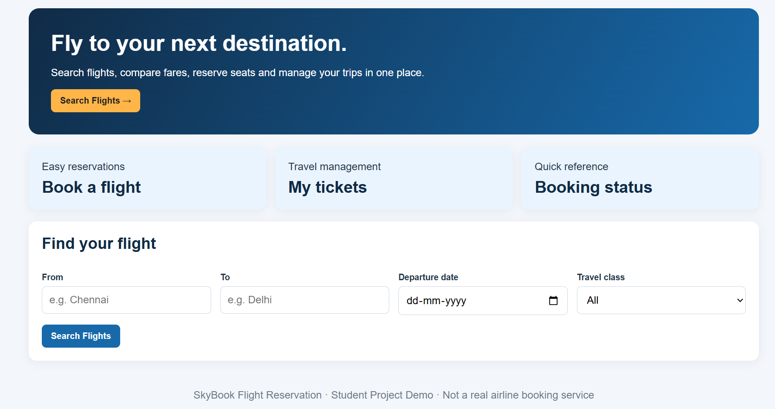

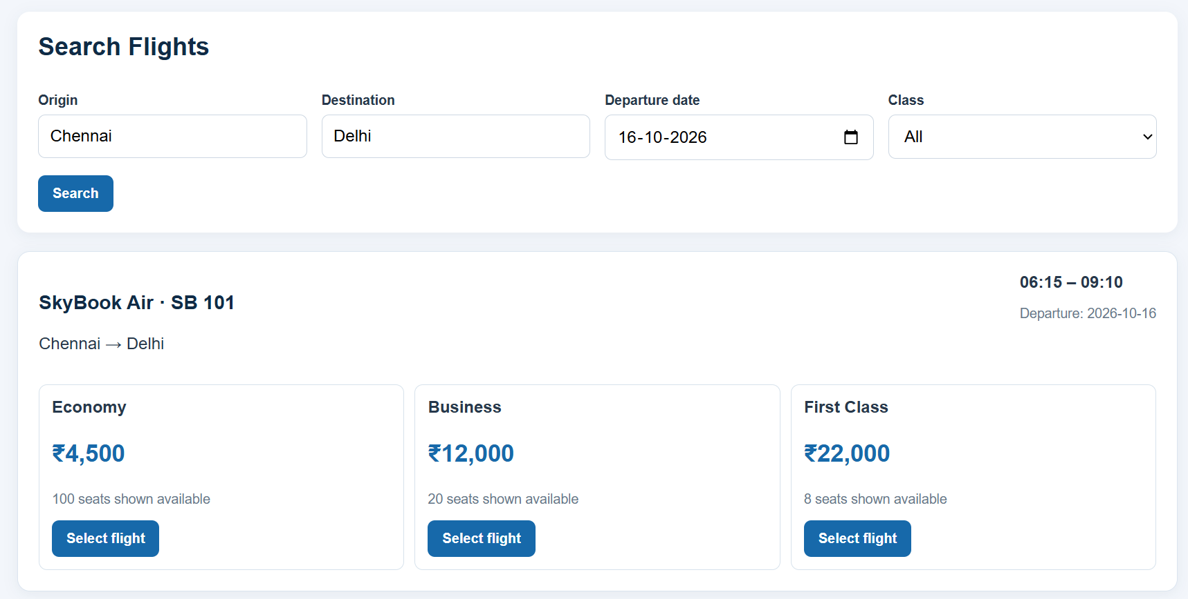

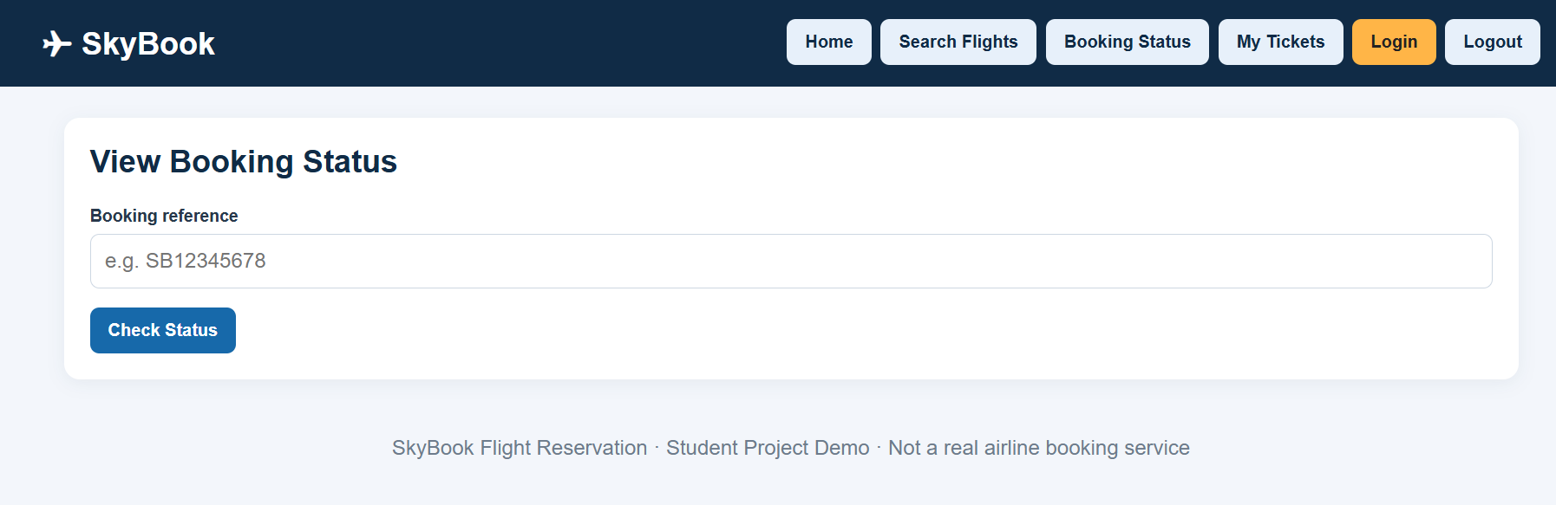

Result
The Online Flight Reservation System webpage was created successfully. Users can search for flights, enter passenger details, book sample tickets, view and print tickets, and cancel bookings. The webpage also includes payment and feedback sections and an admin panel outline. Real-time flight availability, secure payments, authentication, and email confirmations require backend services and airline data integration.

